Lesson 1 Demo 5: Deployment Creation

This section will guide you to:

* Create Deployments

This lab has two sub-sections, namely:

1. Creating deployments using a yaml file
2. Creating deployments using the kubectl command

**Note:** If you don’t have an existing Kubernetes cluster, refer to the Demo 1.1 of Lesson 1.

**Step 1:** Creating deployments using a yaml file

* Create a new yaml file named *nginx-deployment.yaml*

vi *nginx-deployment.yaml*

* Enter the following into the yaml file and save it:

*apiVersion: apps/v1*

*kind: Deployment*

*metadata:*

*name: nginx-deployment*

*labels:*

*app: nginx*

*spec:*

*replicas: 3*

*selector:*

*matchLabels:*

*app: nginx*

*template:*

*metadata:*

*labels:*

*app: nginx*

*spec:*

*containers:*

*- name: nginx*

*image: nginx:1.7.9*

*ports:*

*- containerPort: 80*

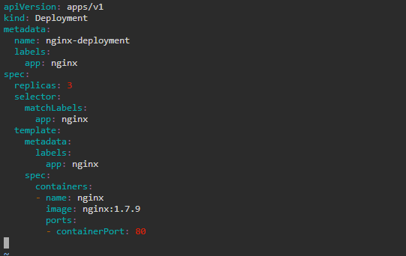

**Note:** Press **Esc** button and enter **:wq** to save and exit the text editor

* Create the deployment by running the following command:

*kubectl apply -f nginx-deployment.yaml*



* Check the newly created deployment

*kubectl get deployments*

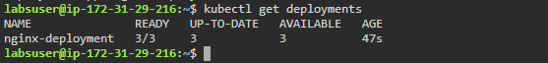

**Step 2:** Creating deployments using the kubectl command

* Use the following command to create a deployment that manages a pod

*kubectl create deployment hello-node *

*--image=gcr.io/hello-minikube-zero-install/hello-node*

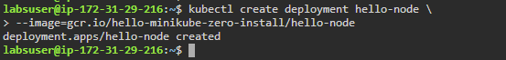

* List all the running deployments

*kubectl get deployments*

